Hope Artificial Intelligence
Classification Assignment Problem Statement
Requirement: A requirement from the Hospital, Management asked us to create a predictive model which will predict the Chronic Kidney Disease (CKD) based on the several parameters. The Client has provided the dataset of the same.
1.) Identify your problem statement : Predict the patients who is having Chronic Kidney Disease based on the input fields (parameters).
2.) Tell basic info about the dataset (Total number of rows, columns) - 399 rows × 25 columns
3.) Mention the pre-processing method if you’re doing any (like converting string to number – nominal data) - Preprocessing the decimal value columns and text columns to Nominal data
4.) Develop a good model with good evaluation metric. You can use any machine learning algorithm; you can create many models. Finally, you have to come up with final model.
Below are the classification algorithms considered to create models:
- Logistic Regression
- Decision Tree Classifier
- Random Forest classifier
- Support Vector Machine
- K-Nearest Neighbours
- XG Boosting Classifier
5.) All the research values of each algorithm should be documented. (You can make tabulation or screenshot of the results.)
- Logistic Regression
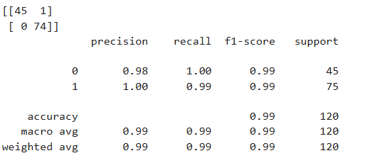

- Decision Tree Classifier
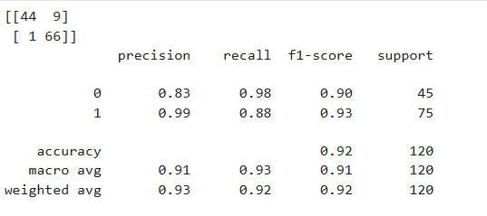
- Random Forest classifier
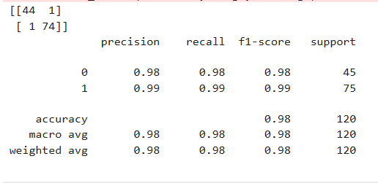
- Support Vector Machine


- K-Nearest Neighbours
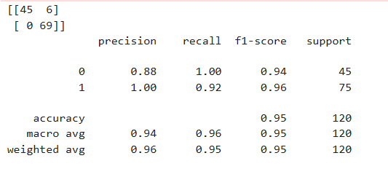
- XG Boosting Classifier
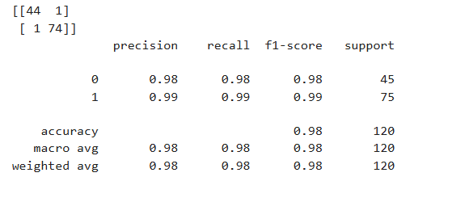

6.) Mention your final model, justify why u have chosen the same.
Note: Mentioned points are necessary, kindly mail your document as well as .ipynb (code file) with respective name.
Final Model is Logistic Regression gives same accuracy value is 0.99

ϖ ϖ Sub file name also should be properly named for Example (SVM_Ramisha_Assi-5.ipynb)
Communication is important (How you are representing the document.)
Kindly uploaded in the Github and Share it with us.
GitHub link: vanmathisivanandham-gif/Machine-Learning-Phase1-and-Phase2

